**Appendix S1**

**Supporting Information for**

*Intraspecific scaling of individual growth, consumption and metabolism with temperature and body mass across fishes*

Max Lindmarka,1, Jan Ohlbergerb, Anna Gårdmarkc

a Swedish University of Agricultural Sciences, Department of Aquatic Resources, Institute of Coastal Research, Skolgatan 6, Öregrund 742 42, Sweden

b School of Aquatic and Fishery Sciences (SAFS), University of Washington, Box 355020, Seattle, WA 98195-5020, USA

c Swedish University of Agricultural Sciences, Department of Aquatic Resources, Skolgatan 6, SE-742 42 Öregrund, Sweden

1Author to whom correspondence should be addressed. Current address:

Max Lindmark, Swedish University of Agricultural Sciences, Department of Aquatic Resources, Institute of Coastal Research, Skolgatan 6, Öregrund 742 42, Sweden, Tel.: +46(0)104784137, email: [max.lindmark@slu.se](mailto:max.lindmark@slu.se)

Contents

Literature search, selection process and criteria 3

*Growth rates & optimum temperature for growth over body mass* 4

*Metabolic rate* 5

*Maximum consumption rate* 5

Data exploration 7

*Growth rate* 7

*Metabolic & maximum consumption rate* 9

Supplementary analysis 13

Model validation 16

*Optimum growth temperature* 16

*Growth rate* 19

*Metabolic rate* 22

*Maximum consumption rate* 25

References 28

# Literature search, selection process and criteria

Prior to starting the actual literature review, we conducted several test-searches with alternative search strings on Web of Science Core Collection, basic search. This was done in order to find a manageable number of articles to review and to have a reasonable ratio article titles that passed the first screening, given our pre-defined criteria for when to choose a study. As we suspected that relatively few studies would have considered both size- and temperature treatments (combined factorially), our goal was to get an as extensive as possible list of studies. Therefore, we also evaluated articles cited by articles in the literature list, and from published review-type articles and reviews of applications of bioenergetics models such as the Wisconsin model (Deslauriers *et al.* 2017).

The search terms and subject categories are presented in the main text. We filtered out articles at three levels of the search: title, abstract and full article. Appendix SX contains lists of article titles at each of these steps in the filtering process. We also used studies that did not appear in the literature search but that we found by following cited literature when reading the full article. The source of the article (literature or cited literature) is indicated in the data sets. We removed studies from the lists if the titles made it clear the articles did not fulfill all of the following conditions: (1) experimental study, (2) fish as study organism in life stages older than larval, and (3) replicates across both size and temperature. In addition to these general criteria, we also had criteria specific for each rate (see below). When several studies were found for the same species, we did not include both but instead chose the study with the largest size and temperature range (in that order), as there can be large differences in absolute values of some physiological parameters between studies. While this reduces the number of data points, it avoids additional observation error due to different experimental setups and experimenters. All data were extracted from tables, or figures using Web Plot Digitizer (Rohatgi 2012) version 4.1.

## *Growth rates & optimum temperature for growth over body mass*

Growth rates were taken from data found in the literature search for optimum growth temperatures. The two searches for growth rates described in the main text resulted in 3313 articles (search date: 2019.03.22), and 3747 articles (search date: 2019.08.05), respectively. After applying additional filters by subject category, we acquired 566 and 893 studies, respectively (of which some are duplicates due to similar search-strings). We removed studies at the abstract and whole-article stage where the original reference could not be identified and evaluated, if we could not extract actual growth rates, if there was not a controlled temperature for each growth trial, or if there were not multiple defined size-classes. In addition, we ensured that no other treatment (e.g. food limitation) confounded the response variable and thus only used data from experiments with food supply corresponding to satiation. It is important to control for feeding rations as it affects the temperature optimum for growth (Brett *et al.* 1969). This was achieved in different ways in the different experimental studies, but normally involved excess feeding rations once or several times per day. The key description we looked for in the study was that food should not be limiting or “reduced” rations. In the case growth was length-based, we converted them to mass using weight-length-relationships from FishBase (Froese *et al.* 2014; Froese & Pauly 2016). We compiled two separate data sets: raw growth rates (growth_data.xlsx) and temperature at optimum growth (growth_data_Topt.xlsx). In the latter, we defined optimum temperature for growth as the fitted optimum temperature by size-class (in the original study). If the optimum-by-size was not estimated in the original study, we used the temperature where growth rate was maximized. All growth rates were expressed in unit $\% {day}^{-1}$.

## *Metabolic rate*

The search for metabolic rate experiments described in the main text resulted in 8405 articles (search date: 2019.06.06), which was reduced to 3458 after applying filters for subject categories. Articles where filtered out at the abstract and whole-article stage if the original reference could not be identified and evaluated, if units were normalized using a priori defined scaling relationships (i.e. mass or temperature corrected rather than raw values), if it was not standard/routine/resting metabolic rate (i.e. oxygen consumption of an unfed fish at no or little spontaneous activity) or if there was no acclimation. Metabolic rates were converted to the most common unit $mg O_{2} h^{-1}$ (as that is how it is typically measured) using standard conversions. These data where compiled in the file metabolism_data.xlsx.

## *Maximum consumption rate*

The two searches for maximum consumption rates described in the main text resulted in 15259 articles (search date: 2018.12.18), with 3449 remaining after filtering by subject categories. The second search (search date: 2019.03.13) resulted in 431 additional titles after filtering by subject categories (of which some where duplicated from the first search). Articles where filtered out at the abstract and whole-article stage if the original reference could not be identified and evaluated, if units were normalized using a priori defined scaling relationships (i.e. mass or temperature corrected rather than raw values), there was no acclimation, or if it was not maximum consumption rate. As with the growth data, definitions of ad-libitum feeding may differ between studies – the key for our purpose is that food rations should lead to satiation and not be limiting. Consumption rates were converted to the unit $g {day}^{-1}$. These data where compiled in the file consumption_data.xlsx.

EXPLANATORY TABLE HERE

* + If percentage per day (same as g/g/d), multiply by mass and divide by 100 to get g/day. Write this in the appendix
  + Basically write down things I will forget in appendix, e.g. conversion from length to mass, pref_temp etc etc. See notes in the excel files. If env temp, take median. If not, take median of range of preferred temperature. If that columns value is not from FB, write in notes. I.e. in most cases that column is from FB. In some cases that comes from another paper or the same paper. See notes. Unless stated in notes, it's from FB. Check all the notes when I fill in the explanatory table, in case I forgot some edit I made. Go through all notes in the spreadsheet, see they are publishable
  + Some species have continuous data, others don’t, for both rates. Explain why
  + Authors use different definitions. If oxygen con of resting fish = routine. If actively trying to get lowest values, e.g. Percentile or extrapolation, standard. Irrespective, they all starve. this means we can't be 100% sure that species effects are not also author effects
  + Write in methods temp is a hugely important metric when mixing species. We used midpoint, because range depends on what type of metric is used, and cite appendix table on temperature.
  + Put the temperature-stuff I showed to Jan and Anna (as well as the double paper stuff) in Appendix so that I know where I have everything.

Do the same with the “double” species document I prepared for the same meeting

The optimum growth and consumption temperatures were also compared to the minimum, mid-point and maximum of the ranges in experienced environmental temperatures (also taken from FishBase). In the growth data, this information was not available on FishBase for marbled sole (*Pseudopleuronectes yokohamae*), hence 3-24 $℃$ (mid-point 13.5 $℃$) was used (Joh *et al.* 2013; Mitamura *et al.* 2020).

# Data exploration

## *Growth rate*

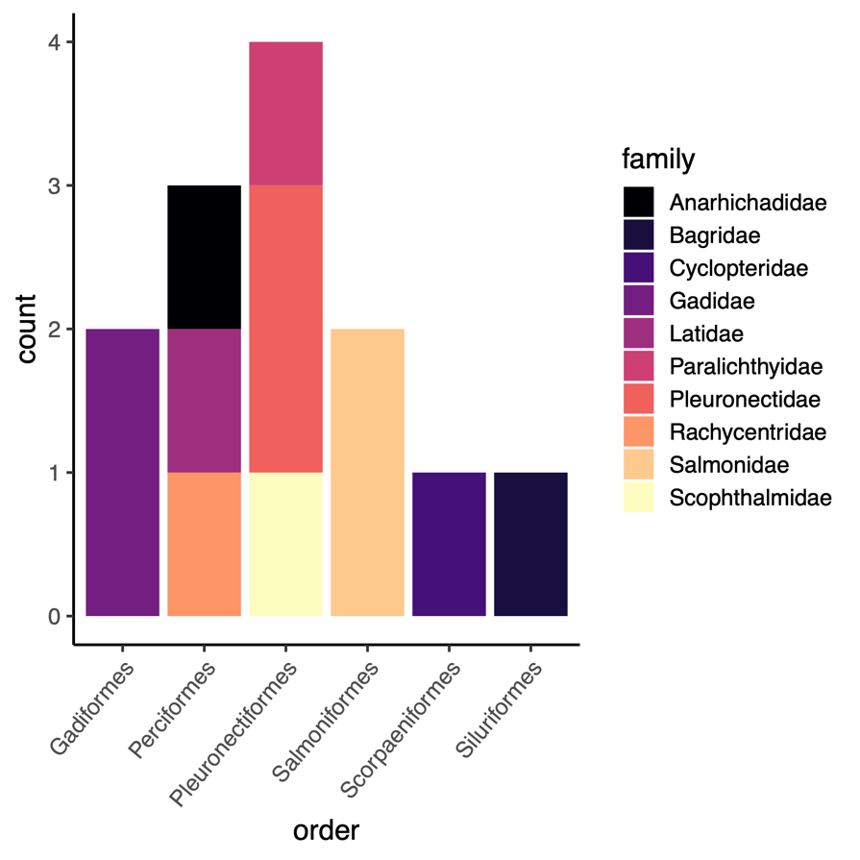

Fig. S1. Taxonomic representation in growth data set.

Fig. S2. Biogeography of species in growth data set.

Fig. S3. Distribution of relative body masses in metabolism and consumption data set. Colors indicate species (legend not shown).

Fig. S4. Log10 of maximum published weight of species in the growth data set.

## *Metabolic & maximum consumption rate*

Fig. S5. Taxonomic representation in metabolism and consumption data set.

Fig. S6. Biogeography of species in metabolism and consumption data set.

Fig. S7. Distribution of relative body masses in metabolism and consumption data set. Colors indicate species (legend not shown).

Fig. S8. Log10 of maximum published weight of species in metabolism and consumption data set

# Supplementary analysis

Fig. S9. Posterior distributions of the average intraspecific mass-scaling exponents and activation energies ($μ_{β_{1,2}}$, and for metabolism also the non-species varying interaction coefficient ($β_{3}$) for metabolic rate (top row) and maximum consumption rate (bottom row). Numbers in the top left corner corresponds to the posterior median. Note that the final model for maximum consumption rate did not include a mass-temperature interaction term. The scale is the same within parameters across rates for comparison (and note that the mass-temperature interaction is estimated and presented on an Arrhenius temperature scale, 1/kT).

Fig. S10. Predictions (line), 80% credible interval (band) and data (points) from polynomial models of maximum consumption rate versus rescaled temperature ($T_{C,i}=T_{C,i,j}-\tilde{T_{env,C,i,j}}$), fitted separately to each species.

***Fig. 6.*** *Experimental temperatures (grey) overlap environmental temperatures (green) and optimum growth temperatures (orange) are typically at the upper end or above the environmental range. Vertical green lines show the minimum and maximum environmental temperature based on either temperature in distribution range (triangles) or modelled distribution maps (circles), both taken from FishBase, and green points show the midpoint. The optimum growth temperatures are depicted for all size-classes per species, where the circle size is proportional to number of observations at that temperature. The average distance between environmental mid-point temperature and mean optimum temperature (per species) is 6.5 $℃$ with a standard deviation of 2.6.*

# Model validation

## *Optimum growth temperature*

Fig. S11. Posterior densities and trace plots for evaluation of chain convergence (by chain, indicated by color), for the highest-level parameters for model.

Fig. S12. Potential scale reduction factor ($\hat{R}$) for the $T_{opt}$ model. This factor is based on the comparison of between and within-chain variation for the same parameter. A value close to one implies chains converged to the same distribution.

Fig. S13. Model fit (mean and coefficient of variation) for $T_{opt}$-model. Vertical line corresponds to mean in data and histogram depicts each posterior mean. Fit is evaluated by simulating data from the likelihood (at each iteration of the MCMC chain), and each simulated data is assigned a 0 or 1 if it is below or above the mean data point. The number in the plot corresponds to the mean of the vector of 0’s and 1’s.

## *Growth rate*

Fig. S14. Posterior densities and trace plots for evaluation of chain convergence (by chain, indicated by color), for the highest-level parameters for the growth rate model at temperatures below optimum temperatures.

Fig. S15. Potential scale reduction factor ($\hat{R}$) for the growth rate model. This factor is based on the comparison of between and within-chain variation for the same parameter. A value close to one implies chains converged to the same distribution.

Fig. S16. Model fit (A=mean and B= coefficient of variation) for model of growth at temperatures below temperature optima. Vertical line corresponds to mean in data and histogram depicts each posterior mean. Fit is evaluated by simulating data from the likelihood (at each iteration of the MCMC chain), and each simulated data is assigned a 0 or 1 if it is below or above the mean data point. The number in the plot corresponds to the mean of the vector of 0’s and 1’s.

## *Metabolic rate*

Fig. S17. Posterior densities and trace plots for evaluation of chain convergence (by chain, indicated by color), for the highest level parameters for the model of metabolic rate at temperatures below optimum temperatures.

Fig. S18. Potential scale reduction factor ($\hat{R}$) for the metabolism model. This factor is based on the comparison of between and within-chain variation for the same parameter. A value close to one implies chains converged to the same distribution.

Fig. S19. Model fit (A=mean and B=coefficient of variation) for metabolism model. Vertical line corresponds to mean in data and histogram depicts each posterior mean. Fit is evaluated by simulating data from the likelihood (at each iteration of the MCMC chain), and each simulated data is assigned a 0 or 1 if it is below or above the mean data point. The number in the plot corresponds to the mean of the vector of 0’s and 1’s.

## *Maximum consumption rate*

Fig. S20. Posterior densities and trace plots for evaluation of chain convergence (by chain, indicated by color), for the highest-level parameters for the model of log-linear (below optimum data) maximum consumption rate at temperatures below temperature optima.

Fig. S21. Potential scale reduction factor ($\hat{R}$) for the maximum consumption model. This factor is based on the comparison of between and within-chain variation for the same parameter. A value close to one implies chains converged to the same distribution.

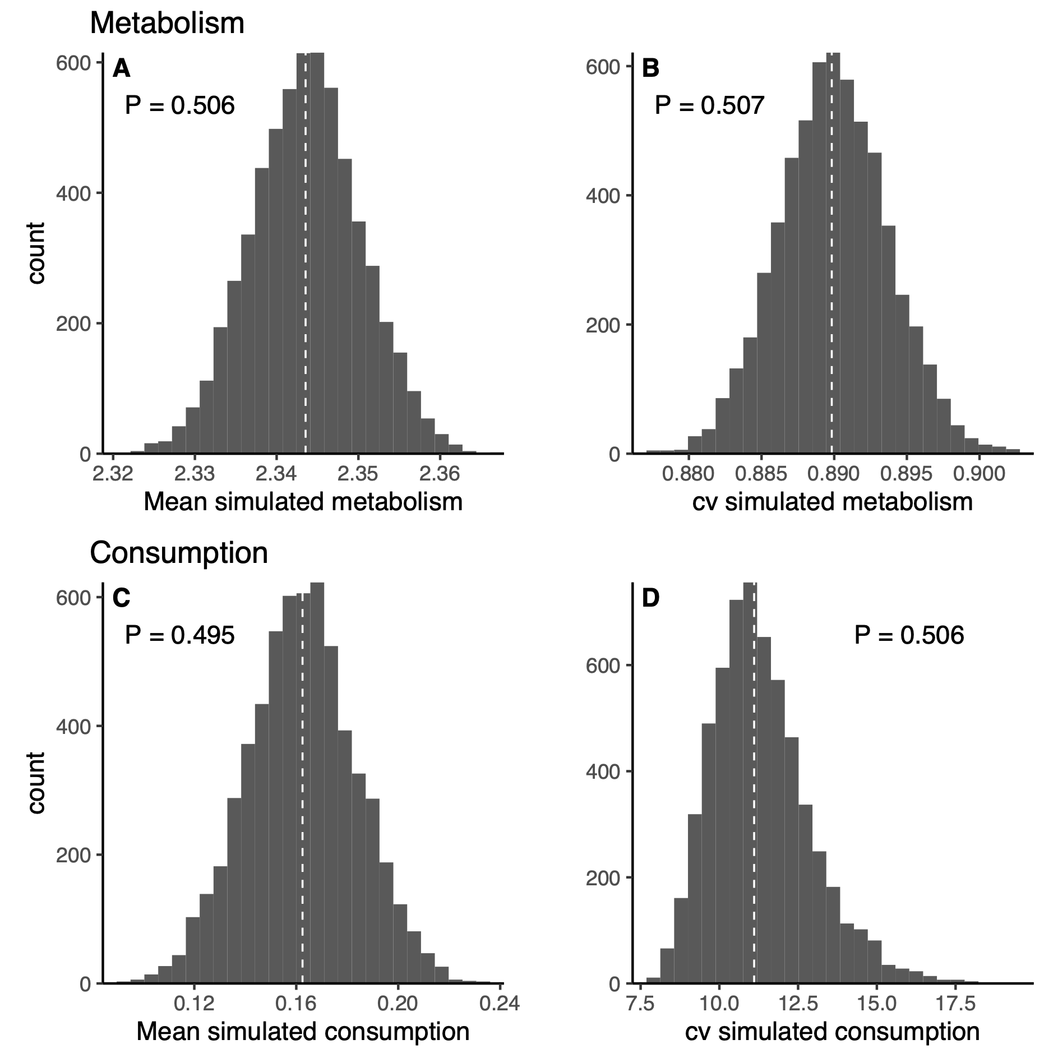

**A**

**B**

Fig. S22. Model fit (A=mean and B=coefficient of variation) for log-linear (below optimum data) consumption rate model. Vertical line corresponds to mean in data and histogram depicts each posterior mean. Fit is evaluated by simulating data from the likelihood (at each iteration of the MCMC chain), and each simulated data is assigned a 0 or 1 if it is below or above the mean data point. The number in the plot corresponds to the mean of the vector of 0’s and 1’s.

# References

Brett, J.R., Shelbourn, J.E. & Shoop, C.T. (1969). Growth Rate and Body Composition of Fingerling Sockeye Salmon, Oncorhynchus nerka, in relation to Temperature and Ration Size. *J. Fish. Res. Bd. Can.*, 26, 2363–2394.

Deslauriers, D., Chipps, S.R., Breck, J.E., Rice, J.A. & Madenjian, C.P. (2017). Fish Bioenergetics 4.0: An R-Based Modeling Application. *Fisheries*, 42, 586–596.

Froese, R. & Pauly, D. (2016). *Editors. FishBase*. World Wide Web electronic publication. www.fishbase.org, (10/2016).

Froese, R., Thorson, J.T. & Reyes, R.B. (2014). A Bayesian approach for estimating length‐weight relationships in fishes. *Journal of Applied Ichthyology*, 30, 78–85.

Rohatgi, A. (2012). *WebPlotDigitalizer: HTML5 based online tool to extract numerical data from plot images. Version 4.1. [WWW document] URL https://automeris.io/WebPlotDigitizer (accessed on January 2019).*